**Project Overview**

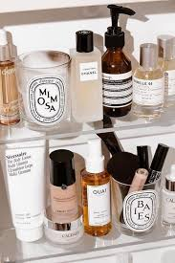The *Flawless* website was developed to embody the brand’s core philosophy: that true beauty begins with self-care and radiant skin. Centered around the tagline **“**Glow With Confidence”.

It was created by using **WordPress** and the site was designed with **Elementor**, enabling a visually stunning and fully responsive layout. A combination of essential plugins was integrated to enhance functionality and user experience:

* **WPForms** – for intuitive and user-friendly contact and subscription forms.
* **WooCommerce** – to power the e-commerce features, making it seamless for customers to browse, shop, and purchase Flawless products directly from the website.

**Features:**

Features  
- Fully Responsive Design  
- Custom Header &amp; Footer Matching Reference Site  
- Homepage with Hero Section, Product Showcase, Gallery, and Blog Grid

**Technologies Used**  
- WordPress – CMS platform for building the website  
- Elementor – Page builder for designing layouts

-WPForms – for intuitive and user-friendly contact and subscription forms.

-WooCommerce – to power the e-commerce features, making it seamless for customers to browse, shop, and purchase Flawless products directly from the website.

**Homepage Overview**

The homepage of the *Flawless* website is designed to immediately reflect the brand’s identity: elegant, confident, and skincare-focused. It opens with a bold hero section, followed by a warm welcome message that highlights the brand’s core belief—*true beauty comes from within*.

Key sections of the homepage include:

* **Best Sellers** – A visually appealing carousel showcasing the most popular skincare products with prices.
* **New Arrivals** – A dynamic slider displaying the latest additions to the product line.
* **Customer Testimonials** – Real reviews from happy customers, reinforcing trust and product effectiveness.
* **Clean, Modern Layout** – Minimalist design with a soft color palette and intuitive navigation, ensuring a smooth user experience.

This homepage is not only informative but also strategically built to engage users, build trust, and drive product interest—all while reflecting the luxurious, results-driven essence of the Flawless brand.

**Blog Page Overview**

The Blog page of *Flawless* serves as an educational hub for skincare lovers. It features a clean, card-based layout that makes browsing articles easy and enjoyable.

* **Content Focus**: Skincare tips, product benefits, ingredients education, and lifestyle insights.
* **Layout**: Grid format with featured images and short intros.
* **Sidebar**: Includes recent posts, archive, and category list.

**Contact Us Page Overview**

The *Contact Us* page is designed to make communication easy and welcoming for visitors.

* **Simple WPSForms Contact Form**: Includes fields for name, email, and message.
* **Message**: Encouraging text inviting visitors to reach out.
* **Responsive Design**: Clean layout that works across devices.
* **Purpose**: Customer support, product inquiries, or general feedback.

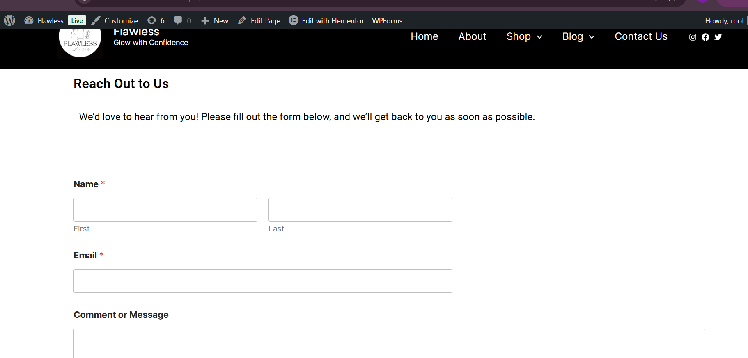

**Shop Page Overview**

The *Flawless* Shop page is the core of the website’s e-commerce functionality, created using **WooCommerce** to provide a smooth and secure shopping experience.

* **Product Display**: Showcases a range of luxury skincare products including cleansers, serums, toners, and moisturizers.
* **Design**: Clean grid layout with product images, names, and prices clearly visible.
* **Categories**: Organized for easy browsing (e.g., Best Sellers, New Arrivals).
* **Add to Cart & Checkout**: Seamless, user-friendly process powered by WooCommerce.

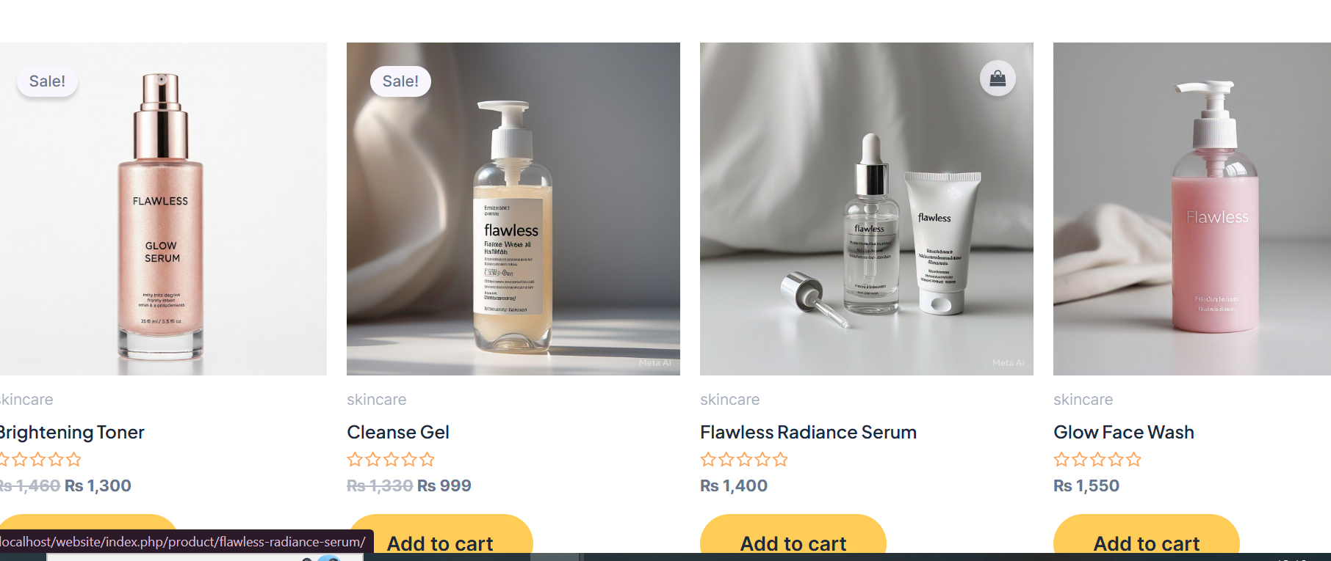

**Link:**

https://github.com/Sarah-Aftab/flawlessss